Experiment 11:
File Handling and Recursive Functions
Objectives:
- Understand file opening, reading, writing, and closing in C++.
- Gain proficiency in writing and using recursive functions.
Introduction:
Recursive Fnctions:
Recursive functions are functions in programming that call themselves during their execution. Instead of using a loop to repeatedly execute a set of statements, a recursive function calls itself to solve a smaller instance of the same problem. Recursive functions have two main components:
Base Case:
The base case is the condition under which the function stops calling itself and returns a result directly. It serves as the termination condition for the recursive calls.
Recursive Case:
The recursive case represents the scenario where the function calls itself to solve a smaller or simpler version of the original problem. This step continues until the base case is reached.
Here's a simple example of a recursive function to calculate the factorial of a number in C++:
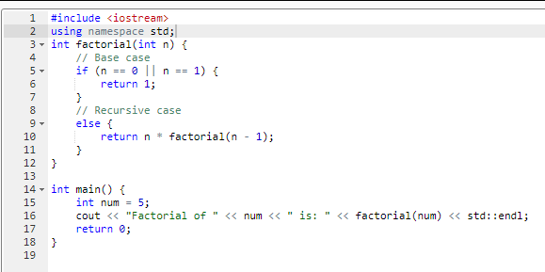
File Handling:
File handling refers to the process of working with files on a computer system, including tasks such as reading from and writing to files. In C++, file handling is typically done using the <fstream> library, which provides classes like ifstream (for reading from files), ofstream (for writing to files), and fstream (for both reading and writing). Here are some key aspects of file handling in C++:
Step#1 fstream library is included in order to read/write from/to file.
Step#2 In order to read from file, a variable is declared of type ifstream (Input stream).
Step#3 Using the variable declared in step 2, open the file from which you want to read data.
Step#4 Just like you use cin to read data from console, the ifstream variable is used exactly the same way. This statement will read first character from file. We can read integers or any other data type too.
Step#5 After reading data from file, this statement is used for closing the file. Using built in function of fstream class eof() is a function already defined in fstream class. It returns 0 if file handle has not reached to end of file
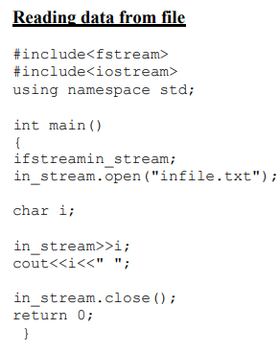
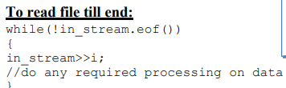
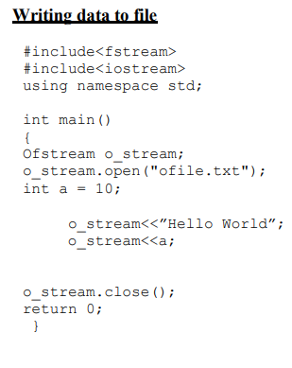

In Lab:
Exercise1: Fibonacci Sequence: Implement a recursive C++ function to generate the nth term in the Fibonacci sequence.
Exercise 2: Palindrome Check: Develop a recursive C++ function to determine whether a given string is a palindrome.
Exercise 3: Write a program that reads data from a file”File_a.txt”, stores the data in an array, takes the square of the data and then saves it in an output file”File_b.txt”. For example:
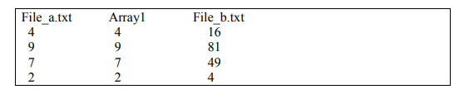
Exercise 4: The file named fact_data.txt contains integers in each line. Write a program that reads each integer and then finds and displays the factorial of that integer as well as write it in a file named fact_out.txt in a new line. Factorial should be found using a function named factorial.
